Answer 4
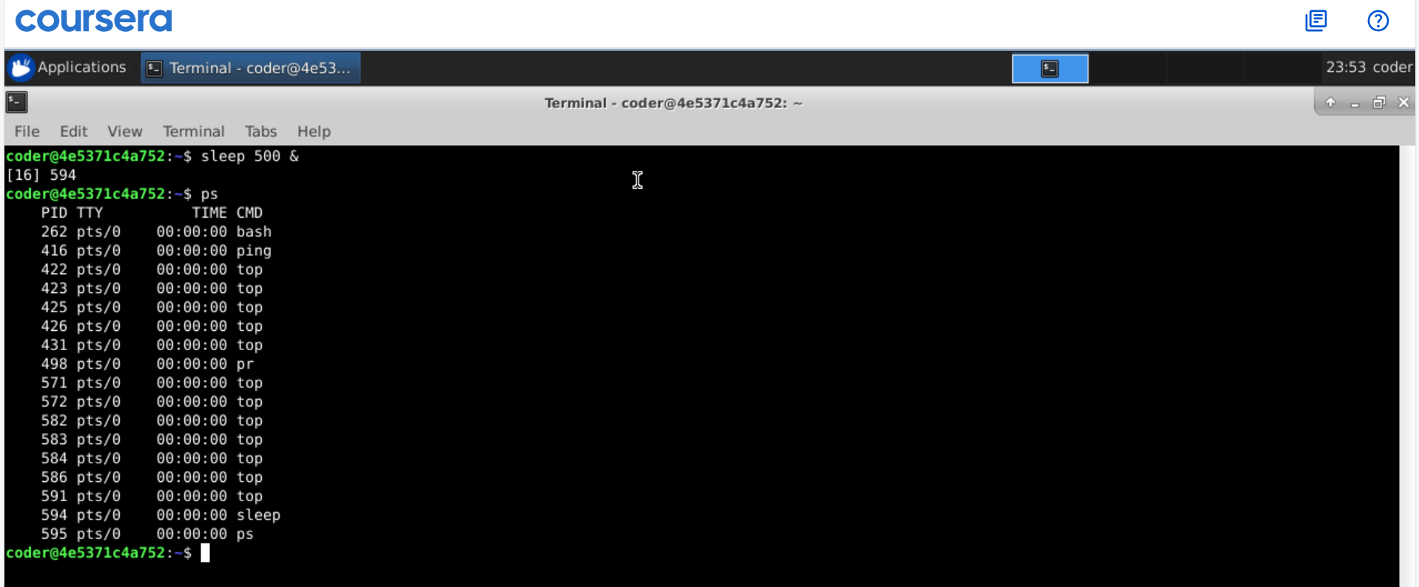
Explanation: By using & command we can run commands in the background. As shown above the command with id 594 can be seen in the ps command which show all the running processes. We can kill it using kill command followed by the PID.

